Unit I: Introduction to Quantum Computation
1. Overview of Quantum Computation

1. Introduction
Quantum computation is a type of computation that uses the principles of quantum mechanics to process information.
Unlike classical computers, which use bits that can only be 0 or 1, quantum computers use quantum bits (qubits), which can be 0, 1, or both at the same time (superposition).
Why it matters:
- Potential to solve problems much faster than classical computers.
- Useful in cryptography, optimization, AI, drug discovery, etc.

2. Key Differences – Classical vs. Quantum Computing
Feature | Classical Computing | Quantum Computing
Basic Unit | Bit (0 or 1) | Qubit (0, 1, or superposition)
Data Representation | Binary logic gates | Quantum logic gates
Processing | Sequential / Parallel (limited) | Quantum parallelism
Mechanics | Classical physics | Quantum mechanics
Speed | Slower for certain complex problems | Can be exponentially faster

3. Core Principles of Quantum Computation

a) Superposition
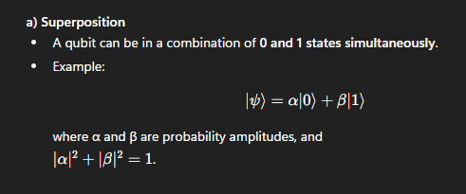

b) Entanglement
- Special connection between qubits where the state of one depends on the state of another, even if far apart.
- Enables faster and more complex computations.

c) Quantum Interference
- Quantum states can add or cancel probabilities.
- Used to amplify correct answers and cancel out wrong ones in algorithms.

d) Measurement
- Observing a qubit forces it to collapse into either 0 or 1.
- The result is probabilistic, not deterministic.

4. Qubit Representation
- State Vector Form:
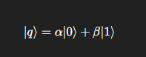
- Bloch Sphere:
A 3D sphere representation of a qubit’s state (used to visualize superposition and phase).

5. Quantum Gates and Circuits
Quantum computation is built using quantum gates, similar to logic gates but operating on qubits.
Common Gates:
- Pauli-X (NOT) – Flips |0⟩ to |1⟩ and vice versa.
- Hadamard (H) – Creates superposition.
- CNOT (Controlled-NOT) – Creates entanglement between qubits.
- Phase Gates – Change the phase of a qubit.
Quantum Circuit = Sequence of quantum gates applied to qubits.

6. Quantum Parallelism
- Ability to evaluate many possibilities at once using superposition.
- Example: If you have n qubits, they can represent 2n2^n2n states simultaneously.

7. Quantum Algorithms
Some famous quantum algorithms:
- Shor’s Algorithm – Fast factoring of large numbers (breaks RSA encryption).
- Grover’s Algorithm – Searches an unsorted database in O(N)O(\sqrt{N})O(N​) time.
- Quantum Fourier Transform (QFT) – Used in many quantum algorithms for speedup.

8. Advantages of Quantum Computation
- Exponential speedup for certain problems.
- Better modeling of quantum systems (e.g., chemistry, physics).
- Improved cryptography and optimization.

9. Limitations & Challenges
- Decoherence – Loss of quantum state due to environment.
- Error rates – Quantum gates are not perfect.
- Scalability – Building and maintaining many stable qubits is hard.
- Hardware cost – Requires cryogenic conditions for stability.

10. Applications
- Cryptography
- Artificial Intelligence & Machine Learning
- Drug discovery and material design
- Optimization problems (logistics, finance)
- Weather prediction & climate modeling

- Single qubit gates
  - 2024: Discuss single qubit gates in quantum computation, and how do they operate on qubits?
- Multiple qubit gates
  - 2023: Define Multiple Qubit Gates with example.
- Measurements in bases Vs computational basis
  - 2023: Describe measurement in bases other than the computational basis.
- Quantum circuits
  - 2024: Discuss Quantum circuits, and how are they used to manipulate qubits?
  - 2023: Define Quantum Circuits.
- Qubit copying circuit
  - 2024: Describe Qubit copying circuit in detail.
  - 2023: Describe Qubit copying circuit.
  - [REPEATED QUESTION: 2023 & 2024]
- Example: Bell states & quantum teleportation
  - 2024: Explain Bell states, and their importance in quantum information processing.
  - 2023: Demonstrate quantum teleportation with suitable example.

2. Basics of Linear Algebra
- Hilbert Spaces
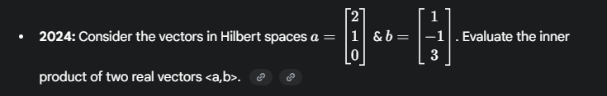
- Products and Tensor Products
  - 2024: Explain tensor product of two vector spaces, and how is it used in quantum mechanics?
  - 2023: Explain the Products and Tensor Products.
  - [REPEATED QUESTION: 2023 & 2024]
- Matrices
  - No specific questions on this topic were found in the 2023 or 2024 papers.
- Graphs, and Sums Over Paths
  - No specific questions on this topic were found in the 2023 or 2024 papers.
- Example
  - No specific questions on this topic were found in the 2023 or 2024 papers.

Unit II: Quantum Architecture
1. The Framework of Quantum Mechanics
- The State of a Quantum System
  - 2023: Describe the state of a Quantum System.
- Time-Evolution of a Closed System
  - 2024: Explain Time-Evolution of a Closed Quantum System in detail.
  - 2023: Describe Time-Evolution of a Closed System.
  - [REPEATED QUESTION: 2023 & 2024]
- Composite Systems
  - No specific questions on this topic were found in the 2023 or 2024 papers.
- Mixed States and General Quantum Operations
  - 2024: Explain Mixed States and General Quantum Operations.
- Universal Sets of Quantum Gates
  - 2024: Describe the Universal sets of quantum gates and its importance in quantum computing.
  - 2023: Explain universal sets of quantum gates.
  - [REPEATED QUESTION: 2023 & 2024]
- Quantum measurement and quantum entanglement
  - 2024: Discuss Quantum entanglement in detail.
  - 2023: Describe role of measurement in quantum architecture.

2. The quantum Fourier transform and its Applications
- The quantum Fourier transform
  - While there are questions on its applications, there are no specific questions just defining the QFT itself.
- Phase estimation
  - 2024: Explain in detail Quantum Fourier Transform is used in phase estimation.
  - 2023: Explain Quantum Phase Estimation.
  - [REPEATED QUESTION: 2023 & 2024]
- order-finding and factoring
- General applications of the quantum Fourier transform
  - 2024: Describe General application of Quantum Fourier Transform.
  - 2023: Describe applications of quantum Fourier transform.
- Period-finding
- Discrete logarithms
- The hidden subgroup problem

Sf's Sandip Institute Of Technology And Research Centre

